Name ______________________________ HOMEWORK Module 1 Week 3
Sept. 5-9
Put your initials by each night that your child practiced the following:
____ Monday ____Tuesday ____Thursday
*Nightly Homework*
Count numbers 1-25.

MONDAY-Identify rhymes: Make a Match! Circle the picture that rhymes with the picture in the box.

van | pan hat
cap | 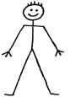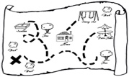  man map
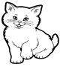  cat | hat man
bag | flag van

Point to each letter and say the name of that letter.
Q W X T Z w r s y t
S V R Y U v q x u z

Read it. Trace it. Write it.
see see ____

TUESDAY- Trace over the letters.
Q q R r S s T t U u V v W w
X x Y y Z z
Practice writing your first name. Only capitalize the beginning letter. ______________
THURSDAY- Say the word, count the syllables, and color the number you hear.

book
4
3
2
1
4
watermelon
1
3
2
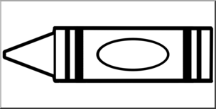
crayon
4
3
2
1

octopus
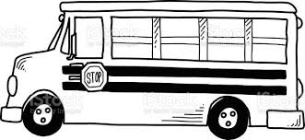
bus
4
4
4
3
3
3
2
2
2
1
1
1
apple

Start Right Reader Week of Sept. 5-9
(Please let your child read this to you.)
Word to Know
see
Vv-Zz
See a van.
See a wagon.

See a whale.

See a xylophone.

See a yo-yo.

See a zebra.

